News Advisory

FROM: Center for Conservation Biology, College of William and Mary – Virginia Commonwealth
University

FOR IMMEDIATE RELEASE: 22 February, 2012

MEDIA CONTACTS: Dr. Bryan D. Watts, Director
bdwatt@wm.edu
(757) 221-2247 office
(757) 272-4492 cell
Barbara Slatcher, OspreyWatch Coordinator
bgslatcher@wme.edu
(757) 221-1617 office
(757) 678-6915
Center for Conservation Biology
College of William and Mary
Virginia Commonwealth University

Become an Osprey Watcher: Connect with a global community of observers

Williamsburg, VA - The Center for Conservation Biology has launched Project OspreyWatch, a project created to engage a global community to collect data on breeding osprey. Linked by an interest in osprey and a concern for the health of the aquatic environments on which they rely, this community will for the first time provide a global perspective on this charismatic species. The mission of Project OspreyWatch is to bring citizen scientists together in order to collect information on a large enough spatial scale to be useful in addressing three of the most pressing issues facing aquatic ecosystems including global climate change, depletion of fish stocks, and environmental contaminants.

Osprey are one of very few truly global sentinels for aquatic health. They feed almost exclusively on live fish throughout their entire life cycle. They are a top consumer within aquatic ecosystems and are very sensitive to both overfishing and environmental contaminants. Nearly all populations breed in the northern latitudes and winter in the southern latitudes, effectively linking the aquatic health of the hemispheres. Their breeding season in the north is highly seasonal making them an effective barometer of climate change.

OspreyWatch is a user-friendly, internet platform that allows observers across the globe to map their nests, log observations, upload photos, and interact within an observer forum. Information entered into the platform will be immediately accessible to users and will be summarized following the breeding season. To join a growing community of global citizens, please visit http://www.osprey-watch.org and become an OspreyWatcher.

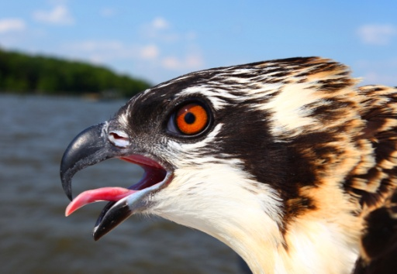
7 week old osprey chick. Photo by Bryan Watts

