News Advisory

FROM: Center for Conservation Biology, College of William and Mary – Virginia Commonwealth
University & The Nature Conservancy, Virginia Chapter

FOR IMMEDIATE RELEASE: 20 June, 2011

MEDIA CONTACTS: Dr. Bryan D. Watts, Director
Center for Conservation Biology
College of William and Mary
Virginia Commonwealth University
bdwatt@wm.edu
(757) 221-2247 office
(757) 272-4492 cell

Barry Truitt, Chief Conservation Scientist
The Nature Conservancy
Virginia Coast Reserve Program
btruitt@tnc.org
(757) 442-3049

Hope arrives on MacKenzie River breeding grounds

(Williamsburg, VA)---Hope, a whimbrel being tracked via satellite by scientists has arrived on her breeding grounds along the MacKenzie River in Canada. She left the Eastern Shore of Virginia on 22 May and made it to breeding grounds on 14 June after traveling nearly 6,000 kilometers. This is the third year that the bird has been tracked to the same location just south of the Beaufort Sea. Her travels through three migration cycles have included more than 24,000 miles (39,000 kilometers). In addition to Hope, 3 other whimbrels were tracked this spring to breeding grounds west of Hudson Bay.

Updated tracking maps may be viewed online.

http://www.ccb-wm.org/programs/migration/Whimbrel/whimbrel.htm

Satellite tracking represents only one aspect of a broader, integrated investigation of whimbrel migration. During the past 4 years, the Center for Conservation in partnership with The Nature Conservancy, the U.S. Fish and Wildlife Service, and Georgia Department of Natural Resources has used conventional transmitters to examine stopover duration, conducted aerial surveys to estimate seasonal numbers, collected feather samples to locate summer and winter areas through stable-isotope analysis, and has initiated a whimbrel watch program. Funding has been provided by The Nature Conservancy, the Center for Conservation Biology, The U.S. Fish and Wildlife Service, the Virginia Coastal Zone Management Program, Georgia Department of Natural Resources, The Toronto Ornithological Club, the Toronto and Region Conservation Authority, and the Northern Neck Audubon Society.

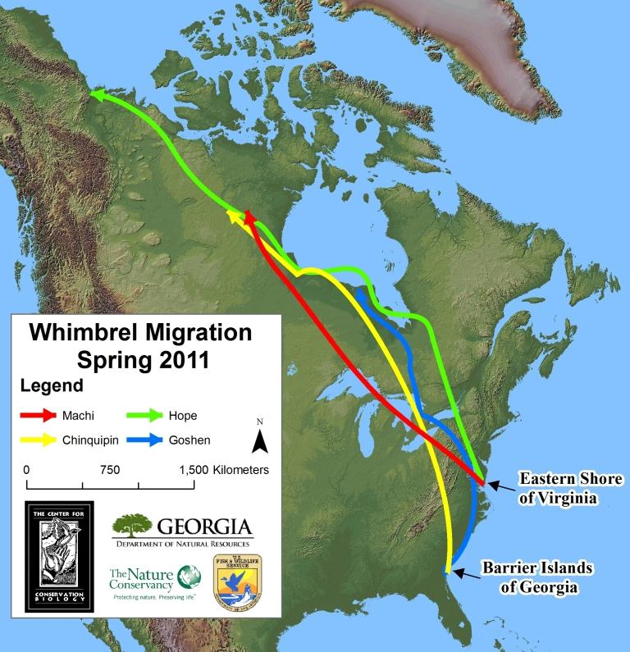
Tracking map – Map of Hope movements from May of 2009 through April of 2011. She has been tracked using a 9.5-gram, solar-powered satellite transmitter. Photo by the Center for Conservation Biology.

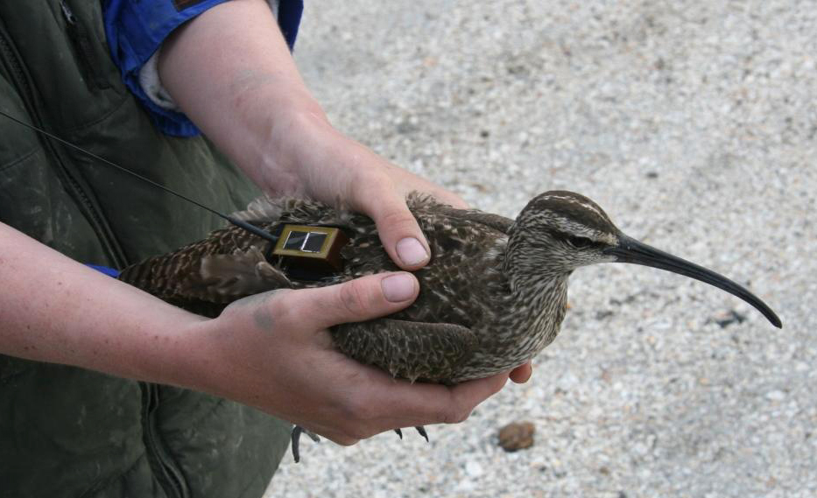
Hope fitted with satellite transmitter. Photo by Barry Truitt.

